Contents
How it Works 2
Landing Location Home Page 4
Button Layout 5
Profile Display 6
Searching Assets 7
RFID Scanning Assets 8
Camera Scanning Assets 12
RFID Container Scan Functionality 13
Information Asset Analytics 17
Adding Assets 21
Troubleshooting/Contact Information 23

Overview: Mobile Vue Use Cases

Enterprise Management: First Vue offers real-time analytics of a physical assets of your enterprise at the push of a button. Whether you are a Battalion Chief at a local fire department needing to know real time information on equipment, what is missing, what is in inventory or who it is assigned to before the next job which can save you valuable seconds when responding to missions. You may be a Technology Integration Specialist for a school district and need to know what laptops, smart boards and desktops are being used for every single school in the entire district. This application can allow you to make informative business decisions on your assets at any time.

How it Works

The tracking of physical assets is powered by a technology called RFID (Radio Frequency Identification). It leverages radio frequencies to transmit and receive signals and is the staple for efficient, low cost, and long-term tracking of assets.
This application can leverage both Barcode and RFID tags with variety of different tags in various shapes and sizes. Barcodes must be read by placing a scanner in the direct line of sight and must be done a tag at a time, like what you see in your local grocery store. Leveraging the use of RFID, you can scan hundreds of tags concurrently over a wider and farther area. For more information how we can implement a specific RFID solution and data integration custom made for your enterprise you can contact us directly through email support@assetvue.com or you can send in a web request on our website https://www.assetvue.com/contact.

Getting Started

This application is available on the Google Play Store for Android devices and Apple App Store for IOS devices. Specific device specifications are required for the use of this app. Such as an IOS device compatible with 9.0 or later. For Android devices the application supports compatibility with versions 10 or later. Once downloaded you are prompted to enter credentials which are the same as the web application. The same web URL instance you use is also the same with the full URL accepted. I.E (https://yoursite.assetvue.com) If you are a new customer you are able to sign up and create an account with 100 free assets for as long as you are active.

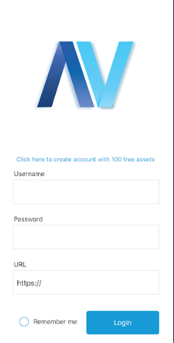

Once you have signed up you will have ability to track, receive live updates of your assets. You will receive an email confirmation, and your database instance will be created from by our IT department, once it is created, you will receive notification that your URL instance is live and you be provided credentials. You can manipulate, add, edit through the mobile application or the web application. It should be noted that the mobile application is just an extension of the web application with the web offering a variety of administrative features and the mobile offering a subset.

Landing Location Home Page

The Locations display shows the layout of your enterprise by whatever criteria you want to display. If you are an Infrastructure Engineer, you may want to break down locations by specific buildings that are under your jurisdiction. From a broader scope, locations can be specific areas such as counties and even cities depending on your enterprise.
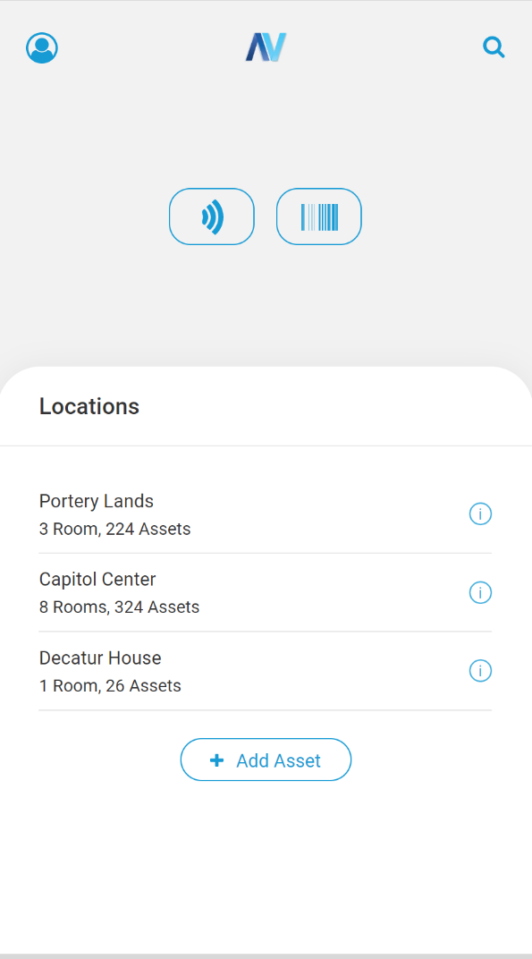
8
6
1
2
4
5
7
3

Button Layout

- Profile Display Button – Redirects you to your profile where you are able to logout of the application
- Home Button – Redirects you back to the landing locations page in the application.
- Search Button – Gives you the ability to search on an asset by Name, RFID tag, Barcode and Camera Scan
- RFID Scan Button – Allows you to scan with your scanner RFID tagged assets and access the Container Scan functionality
- Camera Scan Button – Allows for the use of the camera on your device to scan Barcodes and RFID Tags
- Location Button – Redirects you to a breakdown of rooms in each location to further parse information on assets associated with a location.
- Information Button- Displays an infographic of the break down the status of assets such as “In Storage” and “Production”
- Add Asset Button – Allows you to add an asset to your enterprise by entering information on the asset, its type, description, and primary identifier for tracking analytics

Profile Display

Here you are able to see the credentials you have logged in under, check what version of the application you have and also sign out. You can manage profiles and user access under the web application.
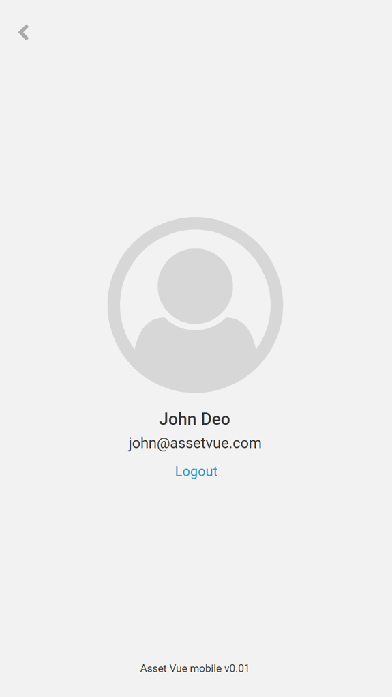

Searching Assets

On this screen you are able to search assets by Name and Primary identification number. The search feature supports fuzzy matching on name and identification number. If you have named all your assets under the supervision of a specific person such as John’s Flashlight” “John’s Helmet” a search of “John” will display all assets within that naming convention. If you have your scanner configured to your device, you can scan within the text field and if you only have the last 5 or 6 digits you are able to search using that method. You are also able to search using your devices camera utilizing this button displayed.
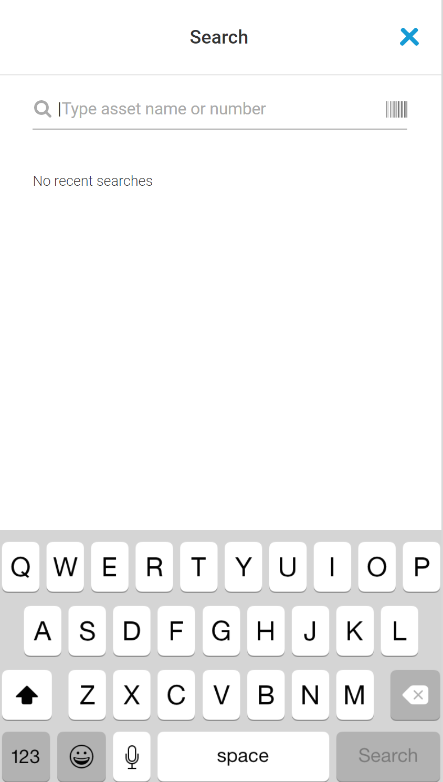

RFID Scanning Assets

In this display you are able to use your RFID Scanner to scan multiple tags in quick succession to indicate location, name, status of the assets that are scanned. You are also able to identify tags that have not yet been stored in the database. From here you can navigate to Container Scan and Camera Scan.
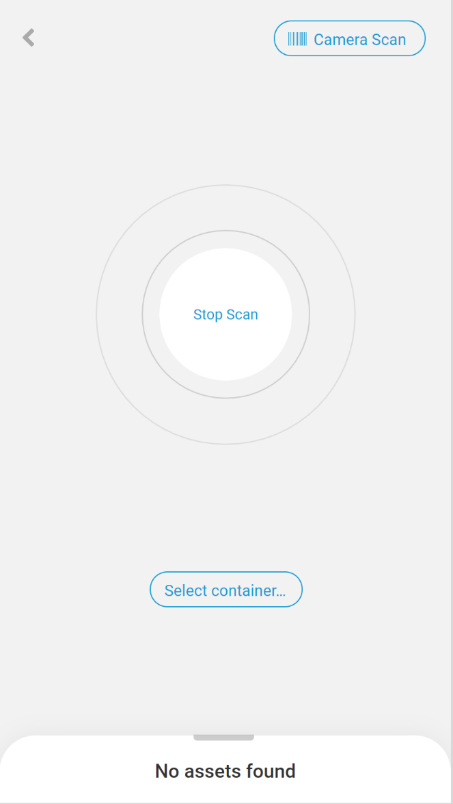

Once all the assets are scanned in the area you will be able to stop scan and see the results.

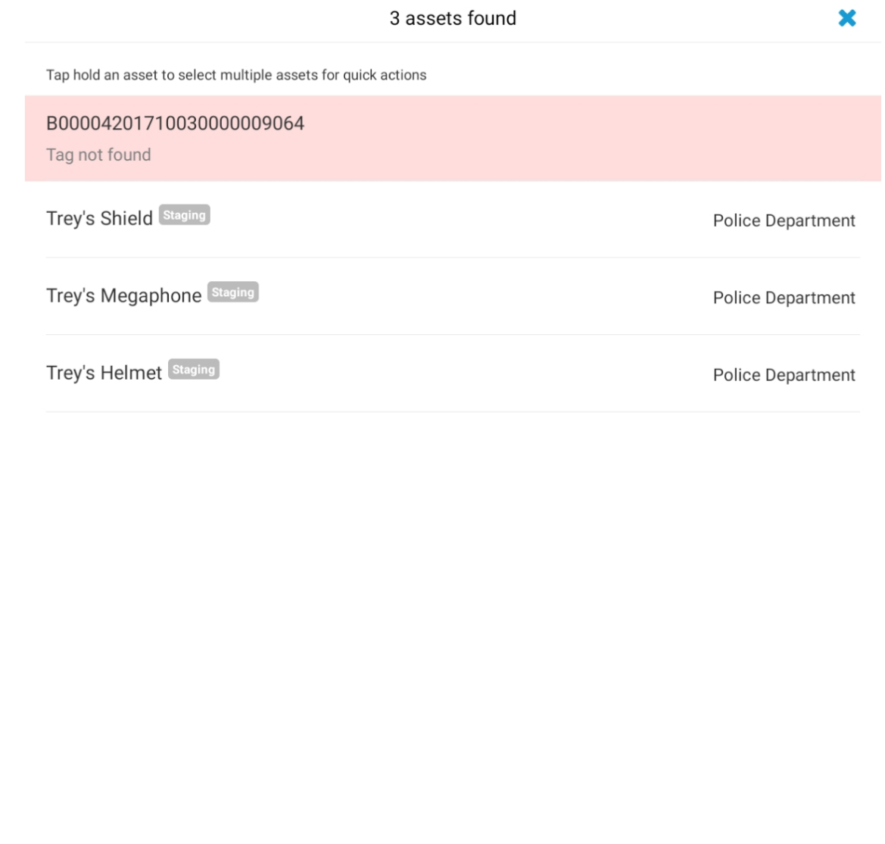

At this point you can click any of the assets stored and change the status of that particular asset from its inventory state, verification state and even changing its base for container scan capabilities.
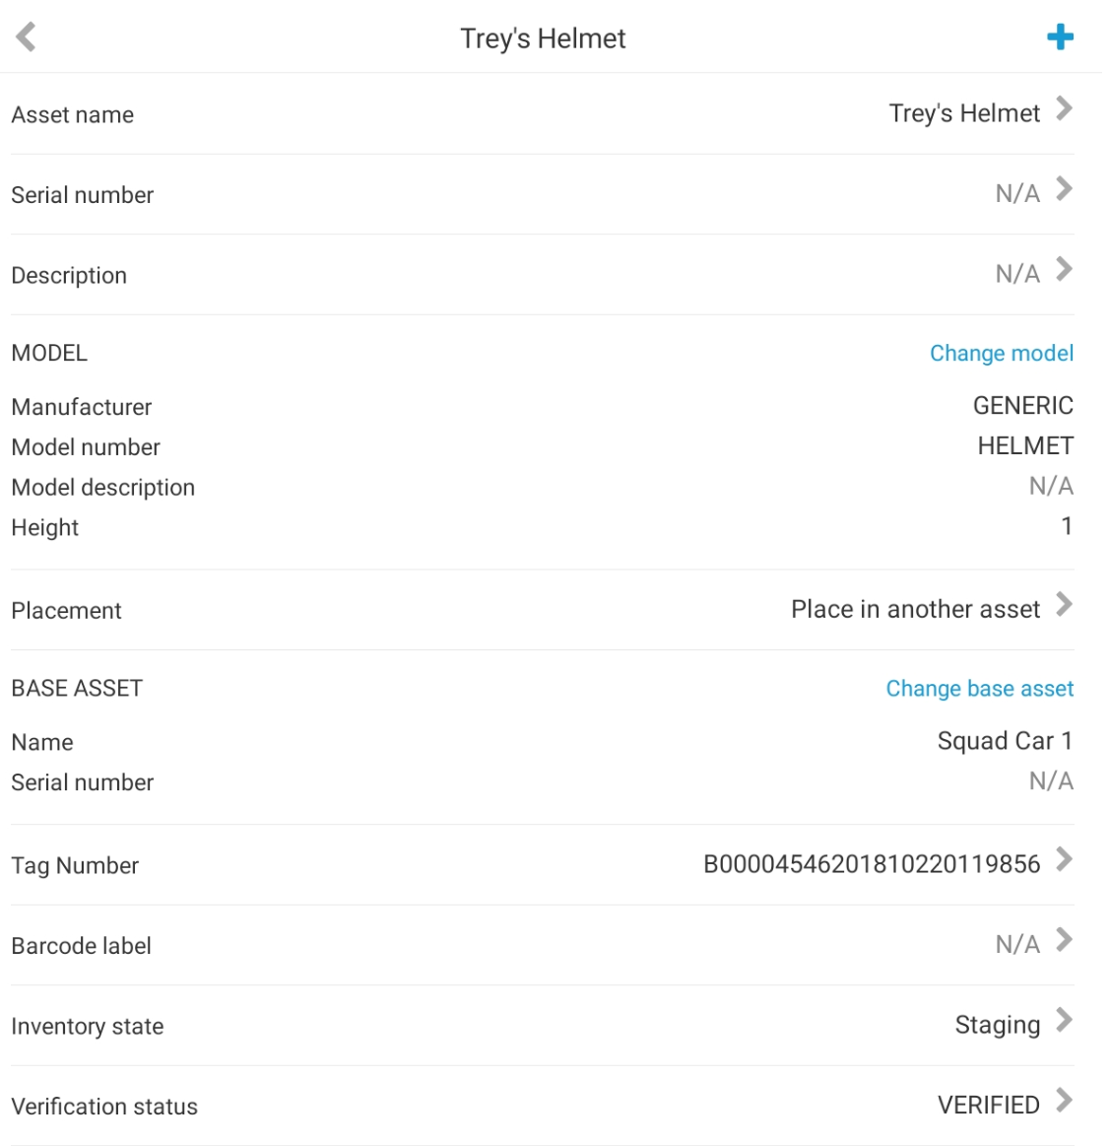

Additionally, from the results page you are able to utilize our quick actions panel to change the status for every asset that is selected.

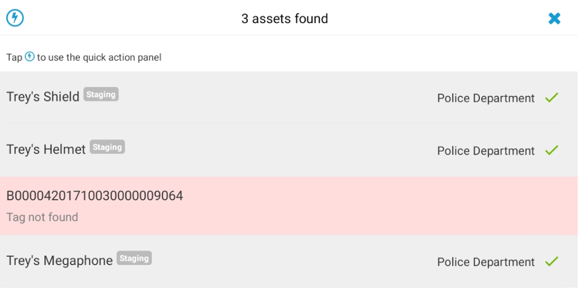

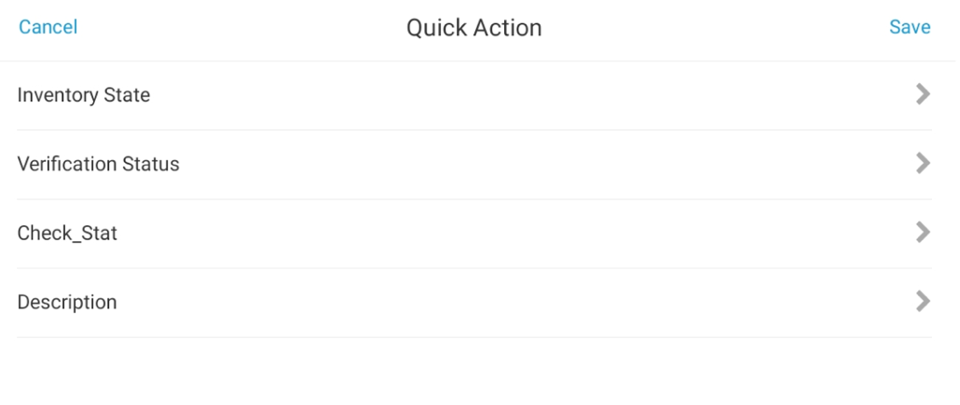

Camera Scanning Assets

Camera Scan also has the same functionality of the RFID Scan by using the camera on your Android and IOS device.
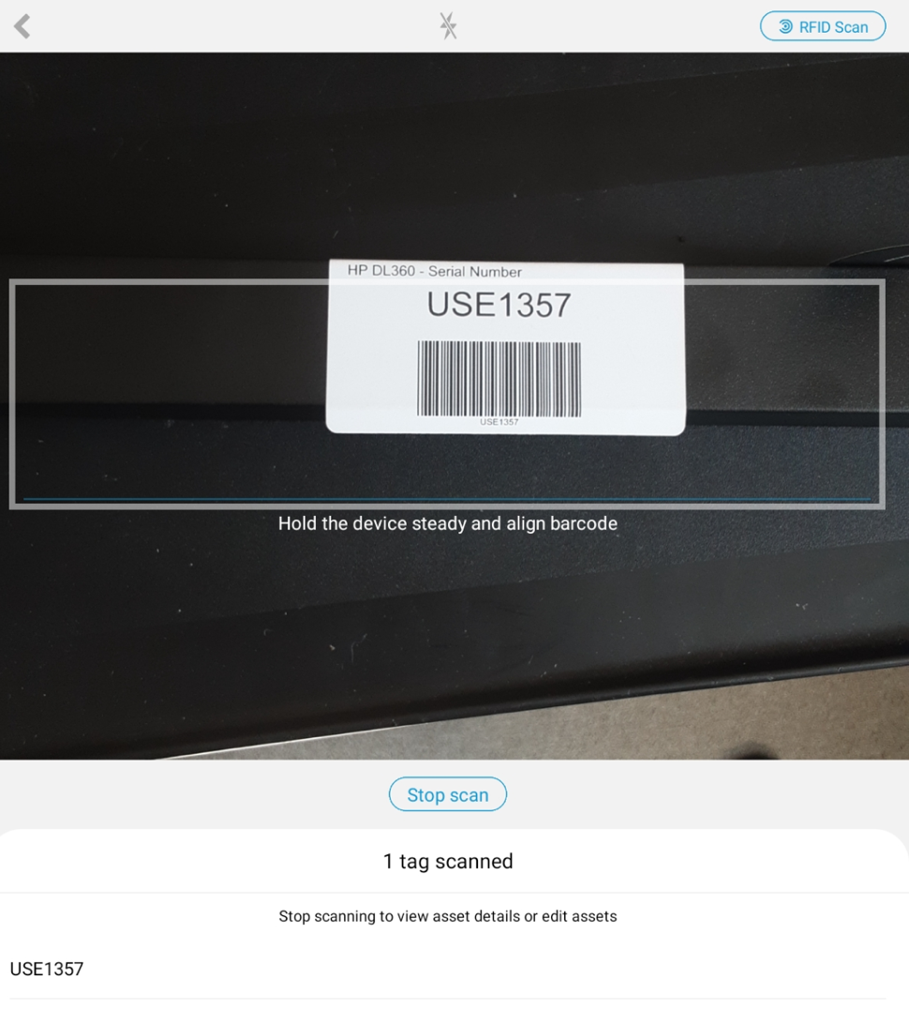
From here once you have scanned the desired barcodes and RFID tags in your area you can stop scan and you be redirected to the results page displayed where you can also perform quick actions for the resulting assets.

RFID Container Scan Functionality

From the RFID Scan display you can utilize the Container Scan function. A container scan allows you to scan a predefined container of either a location, room or base asset for expected assets within. An example maybe you are a Police Officer. You are assigned a specified number vehicle for your shift and want to use RFID to scan the base asset of your vehicle to see if your expected equipment is in there or maybe some equipment from a previous officer’s shift may still be in the base vehicle. To complete this analysis, you will navigate to the RFID Scan button and select container, in this example the vehicle is a base asset so you will navigate to that selection and click done.
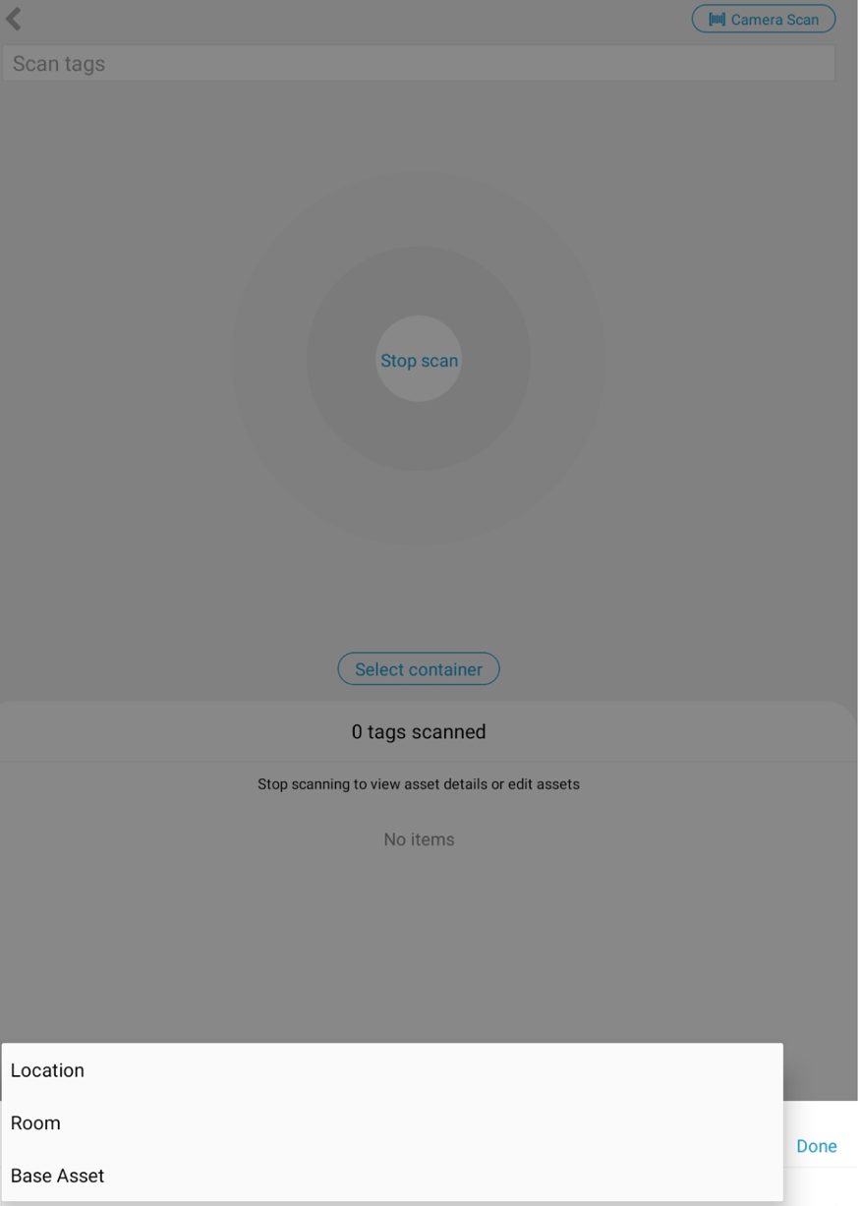

From here you will get a list of every base assets that is documented in the database. You can choose your preidentified base by either text searching, RFID Number, Camera Scan and filtering
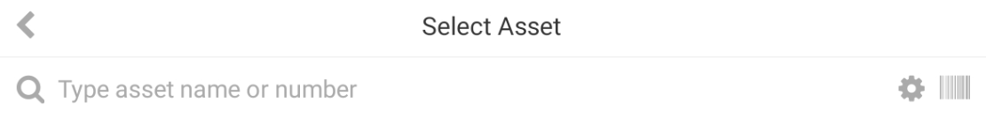

Once you specified base is selected, in this example Squad Car 1, is selected you can Start Scan on the container asset
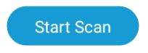

Once that is clicked you will see this layout where the expected assets, inventory state and location are stated.
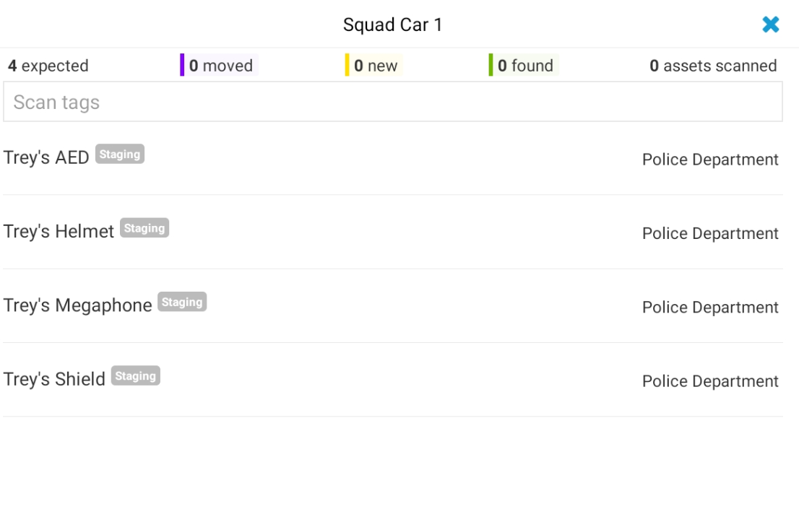

From here you will be able to scan using your RFID scanner, the tags in the vicinity and as you can scan you will be able to visually see what is expected, moved, new tags that are not in the database, what has been found and how many total assets are scanned all together which can be visually seen here once you have selected stop scan.
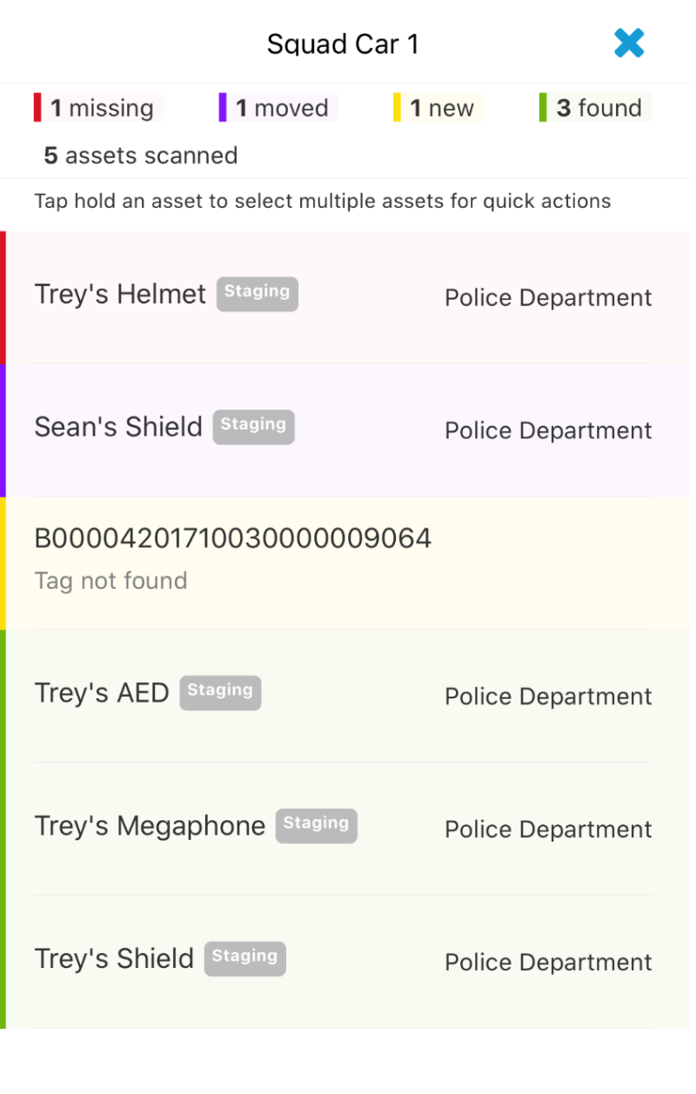

Information Asset Analytics

One feature we also provide are real time analytics of the state of assets across locations and rooms give the ability to change the location, room and state of assets so the analytics accurately reflect that.
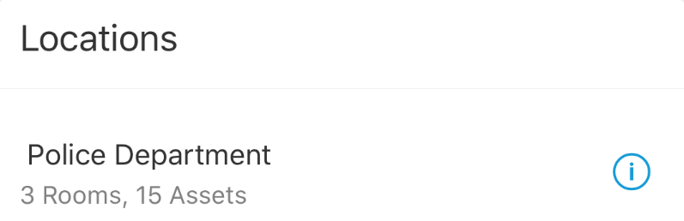
Once the information button is clicked you receive a high-level breakdown of the location and you are able to add an asset from this layout.
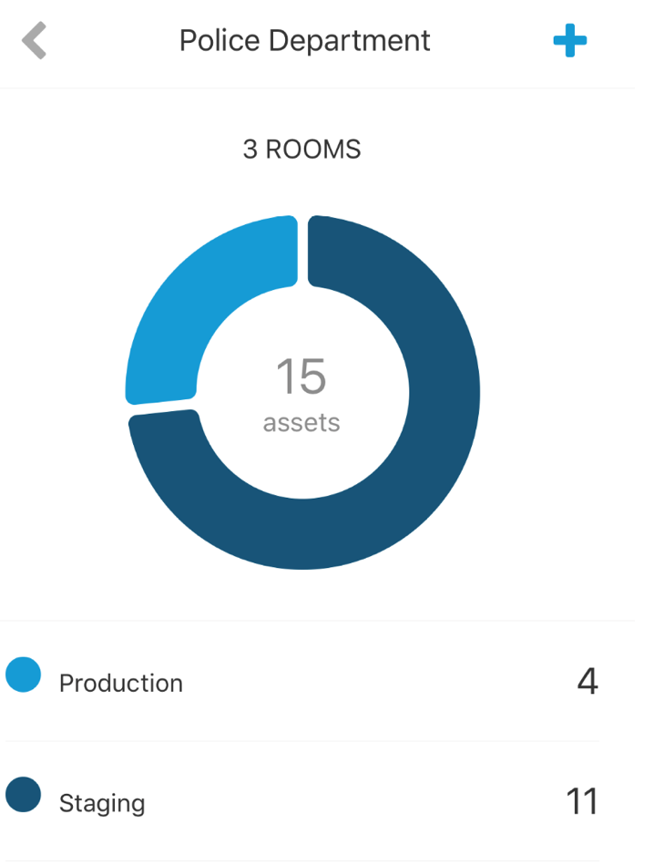

You can view analytics inventory by rooms also are able to move assets from this interface. In this example illustrates the moving of a staging asset into a storage room because that is where it is located physically.
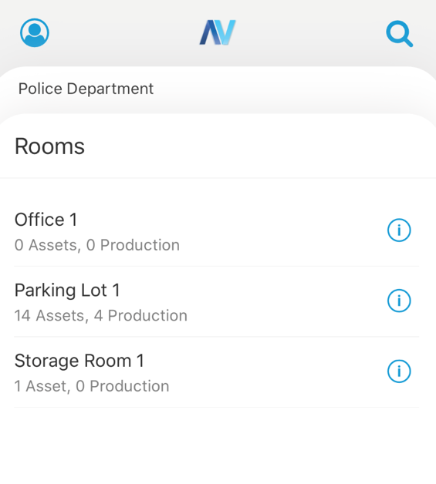
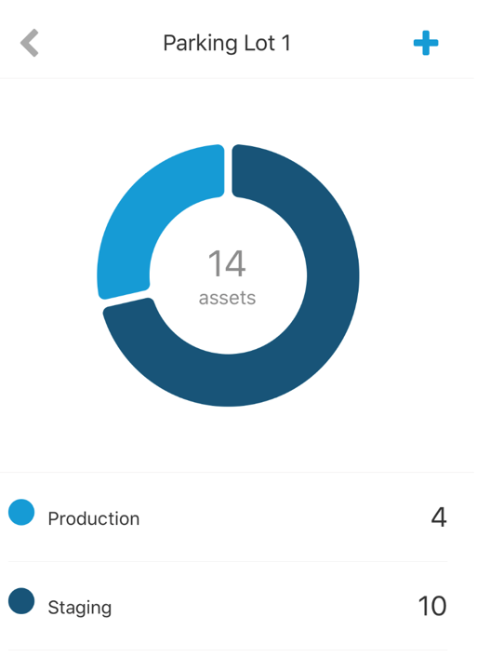

Navigating to all the assets in a specific “room” in this case a Parking Lot 1. Clicking the information button on this level will give you access to that assets data.

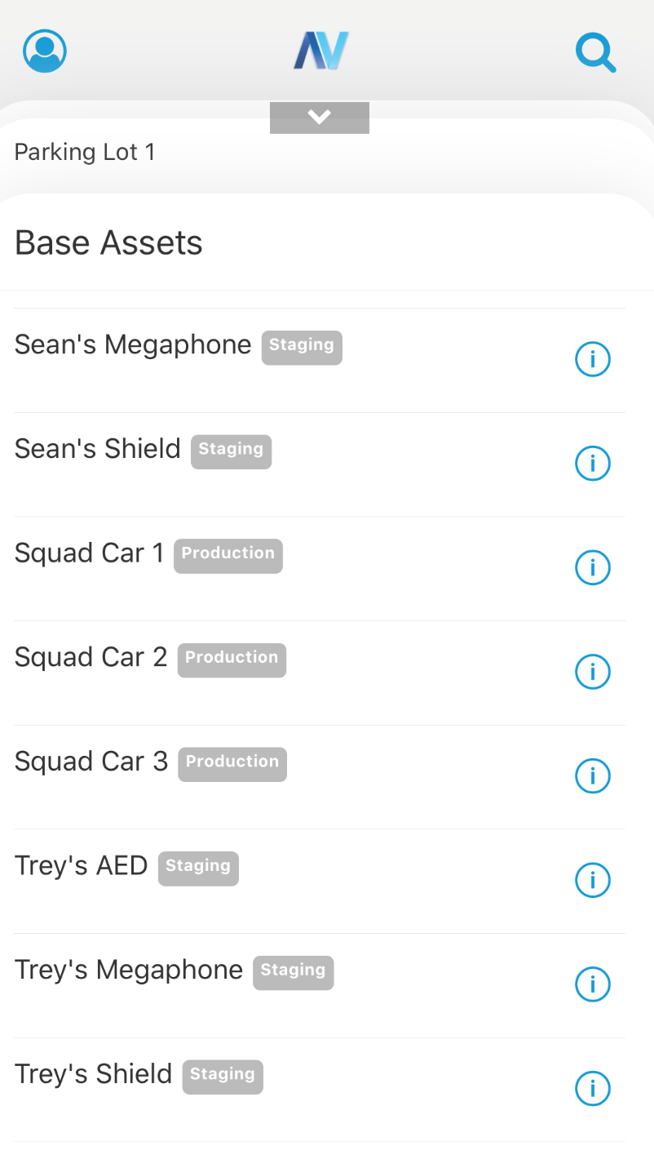

From here you be able to change the necessary fields for this asset. In this location the room was changed from Parking Lot 1 to Storage Room 1.
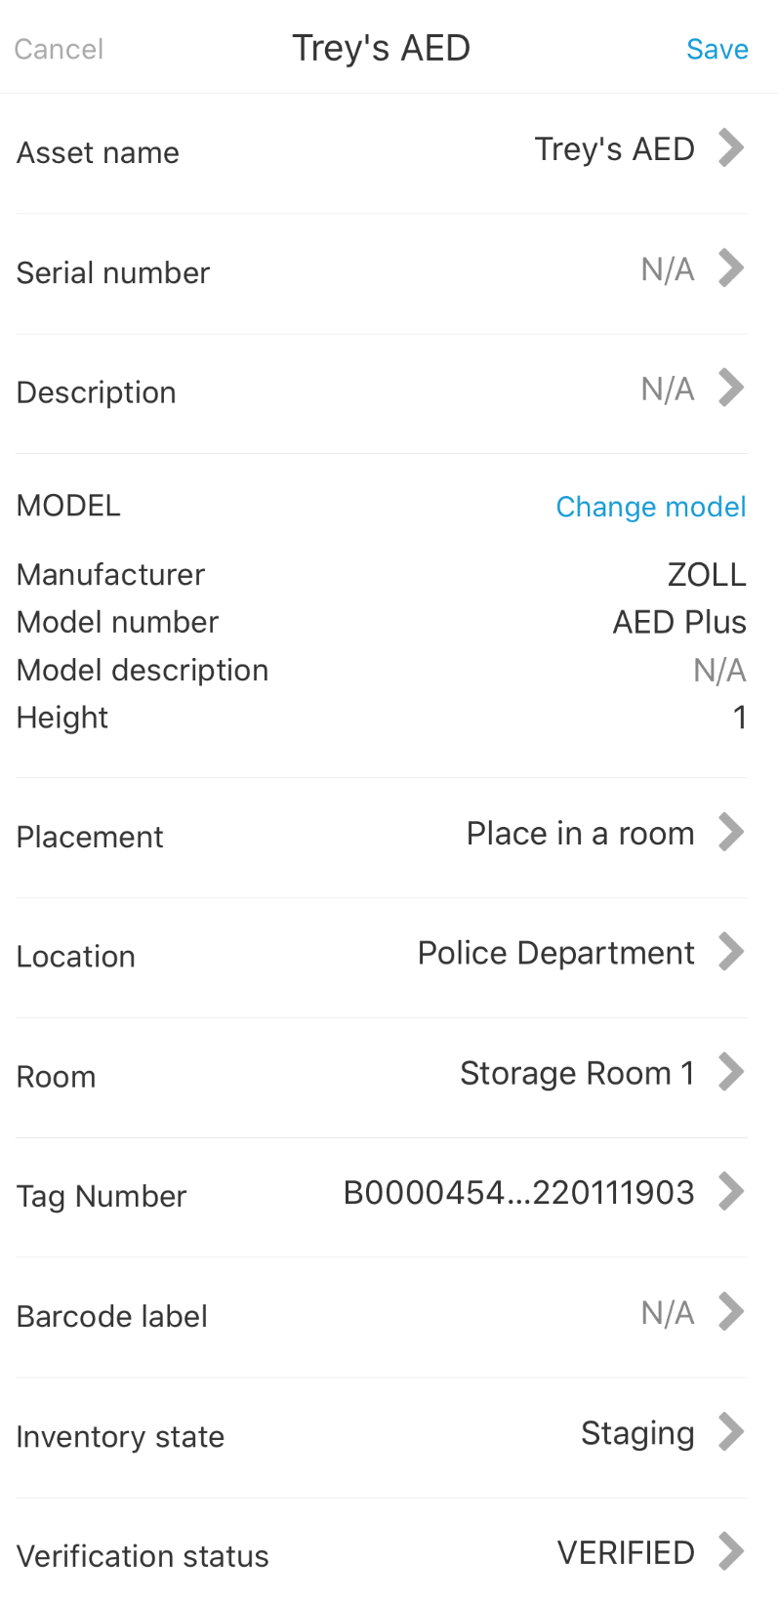

Once that is saved the necessary fields are updated and the corresponding analytical graphic is updated.
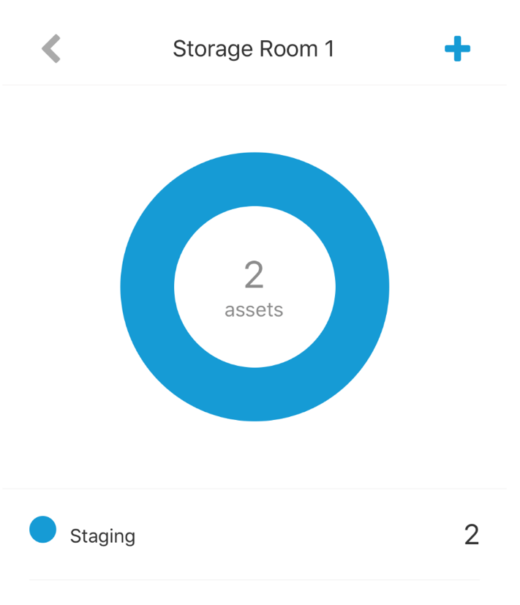

Adding Assets

You have the ability in this application to add asset at different levels, whether you are in a base asset, location or room, this can be identified by these two icons.

Depending on where you initialized the add button some information will be prefilled such as location and placement. This is an example of a completely new addition of an asset. From here you can assign it a name, choose the predefined model, scan in barcode and RFID information from your scanner, give a description and set its status.
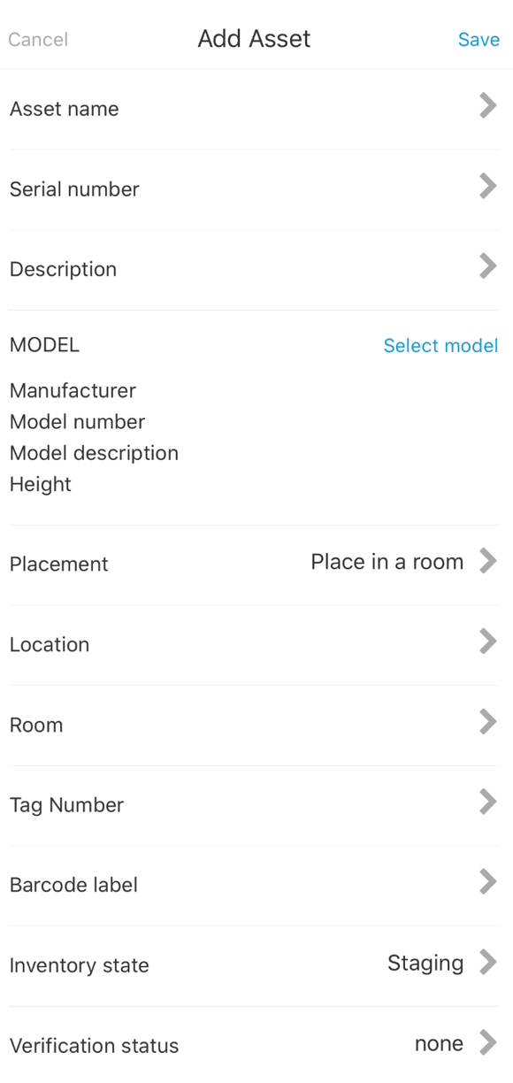

Troubleshooting/Contact Information

Any reported bugs, issues or inquiries about possible demos or data integrations. Please contact our support team at support@assetvue.com or visit us at www.assetvue.com .

